BRAIN TUMOR CLASSIFICATION USING 3 DIFFERENT DEEP LEARNING MODELS

Selva Karthik, Achuthan, Dr. Dennis Anand

* ***ABSTRACT:***

The human brain, which serves as the control center for all the body’s organs, is a highly developed organ that enables a person to adapt to and withstand various environmental situations. The human brain allows people to express themselves in words, carry out activities, and express thoughts and feelings. However, the delicate balance of this vital organ can be disrupted by conditions like brain tumors, which have the potential to severely impair bodily functions, cognition, and even diminish a person’s ability to perform everyday tasks, leading to a complete breakdown of their physical and mental well-being.

Brain tumors can be divided into several categories depending on the kind, place of origin, pace of development, and stage of progression; as a result, tumor classification is crucial for targeted therapy. Scholars have explored algorithms for detecting and classifying brain tumors, focusing on precision and efficiency. Deep learning methodologies are being used to create automated systems that can diagnose or segment brain tumors with precision and efficiency, particularly in brain cancer classification.

This approach facilitates three unique approaches namely ***EfficientNetB4, Noval Hybrid Model (Vision Transformers + EfficientNetB4) and a Custom 2D Convolutional Neural Network***. These models demonstrated praiseworthy performance, yielding a remarkable validation accuracy of ***99.76%, 99.14% and 93.79%*** respectively. A comparative study on various models developed for the same purpose, the results indicate our model outperforms other existing models.

**EfficientNetB4** – 97%

Source: <https://www.nature.com/articles/s41598-024-52823-9>

**2D CNN** – 93.30%

Source: <https://www.mdpi.com/1999-4893/16/4/176>

**Best Model till date:** **Caps-VGGNet** – 99.6%

Source: <https://ieeexplore.ieee.org/stamp/stamp.jsp?arnumber=10162199>

* ***INTRODUCTION:***

A brain tumor is a growth of cells in the brain or near it. Brain tumors can happen in the brain tissue and nearby. Nearby locations include nerves, the pituitary gland, the pineal gland, and the membranes that cover the surface of the brain. Brain tumors can begin in the brain. These are called primary brain tumors. Sometimes, cancer spreads to the brain from other parts of the body. These tumors are secondary brain tumors, also called metastatic brain tumors.

Many different types of primary brain tumors exist. Some brain tumors aren't cancerous. These are called noncancerous brain tumors or benign brain tumors. Noncancerous brain tumors may grow over time and press on the brain tissue. Other brain tumors are brain cancers, also called malignant brain tumors. Brain cancers may grow quickly. The cancer cells can invade and destroy the brain tissue. Brain tumor treatment options depend on the type of brain tumor you have, as well as its size and location. Common treatments include surgery and radiation therapy.

There are several types of brain tumors which include:

1. **Malignant Brain tumors:**

* Gliomas and related brain tumors
* Embryonal tumors
* Germ cell tumors
* Pineal tumors

1. **Benign Brain tumors:**

* Choroid plexus tumors
* Meningiomas
* Pituitary tumors
* Nerve tumors

In this scope of our Paper we have included three types of brain tumors namely Gliomas, Meningioma and Pituitary in the dataset.

With over 300,000 cases reported annually on a worldwide basis, brain tumors are a consistently pressing concern for the international medical community. While some brain tumors may be benign, many can invade the normal brain and develop into brain cancer.

* Approximately 72% of all brain tumors are benign
* Approximately 28% of all brain tumors are malignant
* An estimated 67,440 will be non-malignant (benign) in 2024

Non-malignant meningiomas are the most commonly occurring primary non-malignant brain tumors, accounting for 39.7% of all tumors and 55.4% of all non-malignant tumors

* An estimated 26,940 will be malignant in 2024

Glioblastoma is the most commonly occurring primary malignant brain tumor, accounting for 14.2% of all tumors and 50.1% of all malignant tumors

* ***MATERIALS AND METHODS:***
* Experimental Setup:

The proposed architectures are implemented using Python 3.12 software on

* **Google Colab(Free Version):**

**CPU:** Intel Xeon CPU with 2 virtual CPUs

**RAM:** 13GB

**GPU:** T4 GPU (16GB Memory)

* **College Server:**

**CPU:** Intel(R) Xeon(R) Silver 4310 CPU @ 2.10GHz

**RAM:** 256GB

**GPU:** NVIDIA A100 Tensor Core GPU (40GB Memory)

* **The Libraries used are:**
* TensorFlow/Keras or PyTorch for building and training deep learning models.
* OpenCV or PIL for image processing.
* scikit-learn for additional machine learning utilities (e.g., model evaluation).
* Dataset:

The brain tumor classification dataset sourced from Kaggle.com

Link: <https://www.kaggle.com/datasets/masoudnickparvar/brain-tumor-mri-dataset>

This dataset contains **7023** images of human brain MRI images which are classified into 4 classes: **glioma**, **meningioma**, **no tumor** and **pituitary**.

|  |  |  |
| --- | --- | --- |
| **Type of Brain Tumor** | **No. of Training Images** | **No. of Testing Images** |
| **Glioma** | 1321 | 262 |
| **Meningioma** | 1399 | 306 |
| **Pituitary** | 1457 | 300 |
| **No Tumor** | 1591 | 405 |
| **Total** | **5768** | **1273** |

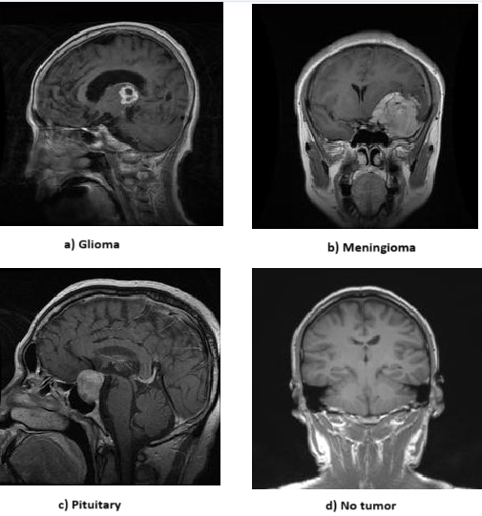

* Proposed Methodology:
* Confusion Metrics:

The system model’s effectiveness was evaluated using confusion metrics, which categorize accurate and erroneous prognostications into four distinct classifications

* True positive (TP) occurs when both the predicted and actual outcomes are positive;
* False positive (FP) occurs when a forecast predicts a positive outcome, but the actual

outcome is negative;

* True negative (TN) occurs when both the observed outcome and prognostication

are negative;

* False negative (FN) occurs when a prediction incorrectly predicts a negative outcome,despite the actual result being positive

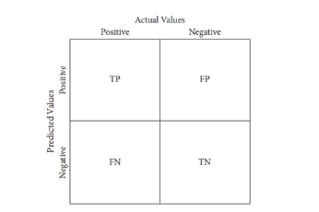

**Confusion Metrics**

* Performance Metrics:

Evaluation metrics should constantly be performed, utilizing the system’s all open elements to assess the viability of brain tumor discovery

* **Accuracy:** It measures the proportion of correctly predicted outcomes (both positives and negatives) out of the total predictions.

$$True ositives TrP + rue egatives TrNTrue ositives \left(TrP\right) + alse egatives \left(FaN\right) + rue egatives \left(TrN\right) + alse ositives$$

$$\left(FaP\right)$$

3.3) Proposed Methodology:

Methodology 1: (EfficientNetB4 Model)

Attach a EfficientNetB4 Architecture Diagram for clear understanding of how it works

What are its strengths and weakness of the model

Methodology 2: (EfficientNEtB4 + ViT Transformer Model)

Same thing applied here too

Methodology 3: (2D Custom CNN)

Same thing applied here too

3.4) Confusion metrics:  
General Discussion of Confusion metrics along with the diagram

3.5) Calculation metrics:

How we calculated our metrics for that we include formulas here :  
Accuracy

Precision

AUC

F1Score

Recall

We need to add Sensitivity and Specificity

1. RESULTS AND DISCUSSION:

(We will keep this part as last as we need to work together for this alone)

Model 1:

What did we do how we came up with this model and include all other metrics and a graph for validation accuracy and loss for this model

Model 2:  
Similarly the Same for model 2 also

Model 3:  
Same Procedure

Then we will have a table comparing all three models and a graph for the same

Comparing all metric like accuracy Precision recall validation loss and so on.

1. CONCLUSION AND FUTURE WORK:

The Conclusion of the models that we built that challenges that we faced and also provide insights of how we can still build better models than this for others viewing this research papers.

REFERENCES